**Plot:**

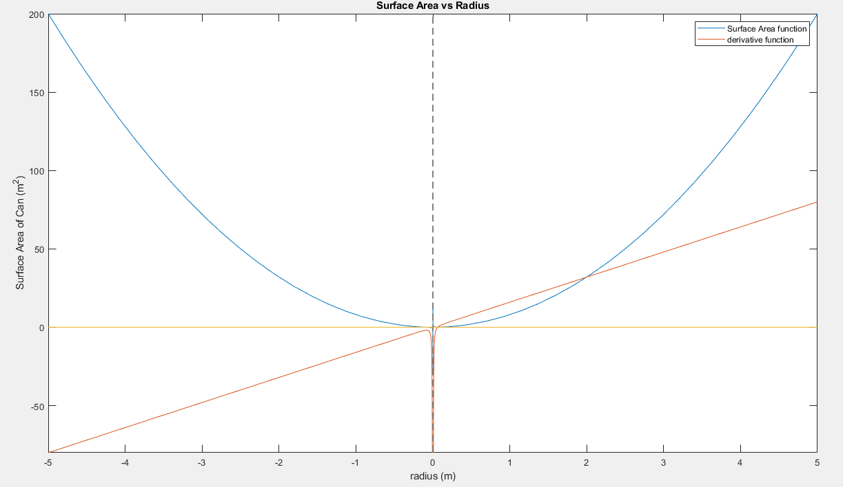

**Code:**

syms r %Setting symbolic variable r

A(r)= 8.*(r.^2)+0.004.*(r.^-1) %Creating function

Derivative=diff(A) %Finding the differential of the function

grid on %Setting the grid

fplot(A(r)) %Plotting the function A(r)

hold on %Plotting everything on the same graph

Derivative=diff(A) %Naming the derivative

fplot(Derivative) %Plotting the derivative

x=0 %Setting x=0 to find the roots

fplot(x) %Plotting x=0

xlabel('radius (m)') %Naming the x-axis

ylabel('Surface Area of Can (m^2)') %Naming the y-axis

title ('Surface Area vs Radius') %Naming the title

legend ('Surface Area Function','Derivative Function') %Naming the legend

**Analysis:**

The x-value when the derivative function (red) intersects the surface area function (blue) is 0.063 metres. This is the optimal radius value that minimizes the surface area.

For height,

Volume = $πr^{2}$ h

Given:

Volume = 0.002 $m^{3}$

Radius = 0.063 m

Solve:

Height

0.002 $m^{3}$ = ${π(0.063 m)}^{2}$ h

h = 0.16 metres

**Long Questions:**

For the code, I knew that I had to plot the function and the derivative of the function as that is the essence of the assignment. Plotting the “x=0” line also helps me find the root of the derivative function immediately and makes the presentation of the graph look much better. I also knew that the optimal radius value would be that when the derivative function intersects the “x=0” function. Once we have that radius, I knew that we could plug it in into the Volume formula to achieve the height knowing that we already have the volume and $π$ is a constant. There are many things an engineer should take into account when they are dealing with finding the optimal radius. For example, they know that the radius, height or volume cannot be a negative value. They must render positive values in the real world, thus if engineers get a negative value from the calculations, then they have done something erroneously. They also know that the derivative function’s intersection at “x=0” is going to give you the result of the optimal radius. Thus, if they are using MatLab, they must use the ‘diff’ command when finding the derivative function.